1. **Box model**
2. **Overflow**

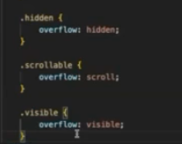

If content exceeds the limit of content area then by default overflow: visible is applied and the content is shown outside of the content area.

Overflow: scroll - scroll the content in case the content is more in both x- axis and y-axis even if the content is not overflowing

Even if the content is not more to have scroll, scroll is applied

Overflow: hidden means the extra content gets cut.

Overflow: auto - applies

scroll in the axis where it’s required.

1. 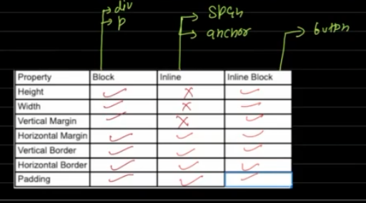  
   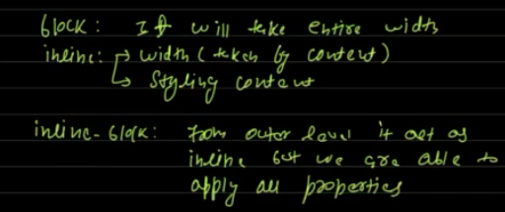
2. Margin collapse.